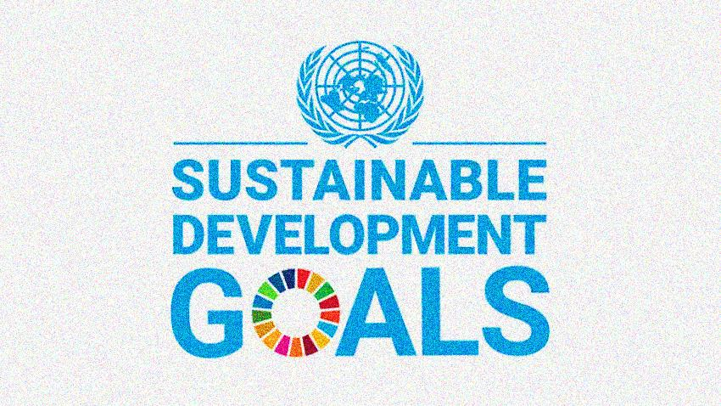
Annual Report on Sustainable Development Goals SDGs 2019-2020

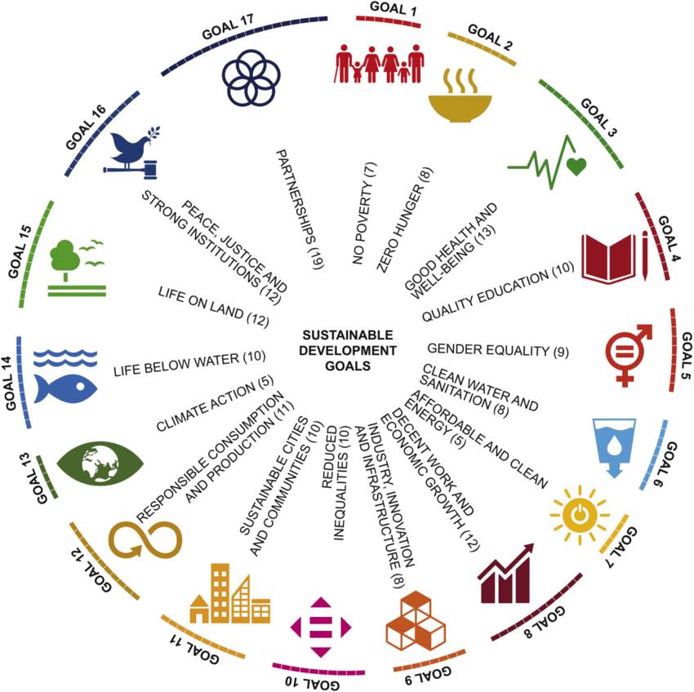

Government College University Faisalabad
Allama Iqbal Road, Faisalabad Pakistan

Government College University Faisalabad is struggling hard to accomplish SDGS
T
he agenda of the Sustainable Development Goals (SDGs) confirms social solidity, economic prosperity, safety of the environment & quality of Education. Gender equity, education, research and innovation are indispensible in sustainable development, making universities key sponsors to achieving the goals.
In the implementation of the SDGs the academic community plays a vital role as the scientific community has already provided significant contributions to the setting meaningful and feasible goals. The contribution of the academic community is central in developing sustainable solutions to address water challenges through advancing water sciences, research and knowledge and applying them in the preparation, establishment and testing of the appropriate frameworks and tools that would be needed to address the challenges of the new SDGs targets on water.
It is well-established that universities and other educational institutions are the most central for achieving sustainable development goals. Higher education supports all the SDGs, in fact, research and education are clearly specified in several of the goals and their targets. Pakistan has over 190 higher education institutions and the prerequisite of these institutions is to ominously increase their contributions and implicitly involve with the SDGs.
Government College University, Faisalabad is striving hard to achieve all Sustainable Development Goals and their implementation within the rules and regulations and policies of the University.
Its existence in Faisalabad, locates it in the hub of chemical, textile, and fertilizer industrial estates with all business being computerized at a fast speed. The City is catering to the needs of more than seven million people.
The University offers educational degrees in various disciplines being a hub of educational, social, scientific and cultural activities and having a close liaison with industry. Including the new campus, the University has five campuses; the main campus, the new campus, and the Layyah, Hafzabad & Sahiwal sub-campuses. With ever increasing number of student enrollment, a total number of around 40,000 students are presently enrolled at GCUF out of which 45.69% are female students. The University offers PhD Program in 30 disciplines, MPhil program in 46 disciplines, Master’s Program in 40 disciplines and Bachelors Program in 61 disciplines. The heartwarming fact is that the graduates are not only gainfully employed, but a good number of them are entrepreneurs creating jobs themselves.
The current faculty of GCUF presents a blend of enthusiasm, sincerity and dedication. Well-equipped laboratories and a commitment to remain intact with modern teaching and research techniques are the main academic distinction of GCUF. The GCUF faculty comprises over seven hundred teachers out of which 395 hold PhD degrees, with a highly experienced and qualified visiting faculty. The University has a strong faculty and facilities for life sciences, chemistry, physics, mathematics, statistics and electrical engineering. The major thrust is to provide incentives to the young faculty for enhancement of their academic qualifications.



UNO-Sustainable Development Goals
1. Eliminate Poverty
2. Erase Hunger
3. Establish Good Health and Well-Being
4. Provide Quality Education
5. Enforce Gender Equality
6. Improve Clean Water and Sanitation
7. Grow Affordable and Clean Energy
8. Create Decent Work and Economic Growth
9. Increase Industry, Innovation, and Infrastructure
10. Reduce Inequality
11. Mobilize Sustainable Cities and Communities
12. Influence Responsible Consumption and Production
13. Organize Climate Action
14. Develop Life Below Water
15. Advance Life On Land
16. Guarantee Peace, Justice, and Strong Institutions
17. Build Partnerships for the Goals

SDG 1-NO POVERTY


Poverty is a worldwide phenomenon and can be seen every corner of the global. The United Nations criterion for extreme poverty is set as those “living on less than 1.90 USD a day” (2015). While this issue is global, half of the world’s population which lives in extreme poverty can be found in five countries: India, Bangladesh, Nigeria, Ethiopia, and the Democratic Republic of Congo (Sanchez, Keck, Sepehr, 2019).

ROLE OF GOVERNMENT COLLEGE UNIVERSITY, FAISALABAD IN ERADICATE POVERTY
The Students’ Financial Aid Office (SFAO) is an integral part of and partner in carrying out and actualizing Government College University’s overall purpose and strategic planning. The fundamental purpose of the financial aid program is to make education possible for students who might otherwise be deprived of this higher education opportunity due to inadequate funds and /or previous limited educational opportunities.

SCHOLARSHIPS AVAILABLE IN GCUF
1. HEC Needs Based Merit Scholarship
2. Punjab Educational Endowment Fund (PEEF)
3. Rehma ull Almeen Merit Scholarship
4. Diya Foundation Scholarship
5. The Pakistan Scottish Scholarship Scheme (PS3)
6. Karwan-e-Ilam Foundation
7. Killa Gift Fund Trust
8. Punjab Zakat Department (MORA)
9. District Council Internal Merit Scholarships of Punjab Districts.
10. Pakistan, Bait-ul-Mal Scholarship
11. Fauji Foundation Scholarship
12. Sitara Group of Chemical Merit Scholarship
13. National Bank Loan Scheme
14. Financial Assistance from University Zakat Fund
15. Prof. Ehsan Merit Scholarship (Physics Department)
16. Prof. Asmat Ullah Khan Merit Scholarship (Urdu Department)
17. Dr. Muhammad Nawaz Merit Scholarship (Pharmacy Department)
18. HDF-THANKS Scholarship # 7 “Mansur Ahmed”
19. Allama Muhammad Iqbal Scholarship for Afghan National Students
20. Minorities Students Scholarship
21. Corn Rafhan Maiz Scholarship
22. Agro vision Scholarship
23. Ehsas Scholarship Undergraduate Program Scheme
24. Punjab Educational Endowment Fund (PEEF)
PEEF Scholarship is an initiative of the Government of the Punjab. It is established with the objective of providing scholarships/monetary assistance to talented and needy students to Bachelor and Master level students.
25. Ehsaas Undergraduate Scholarship Scheme
Higher Education Commission, Islamabad has launched Ehsaas Undergraduate Scholarship for students who are studying in morning programs.
26. HEC Needs Based Scholarship
Higher Education Commission, Islamabad, is also providing Need Based Scholarships i.e HEC Need Based Merit Scholarship for needy students to the students of Basic Sciences and
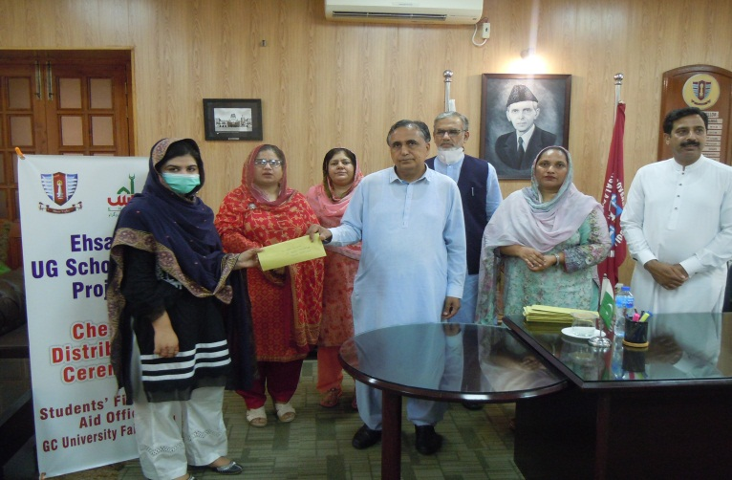
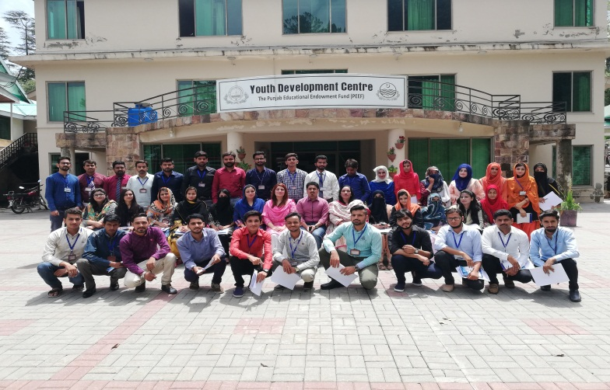

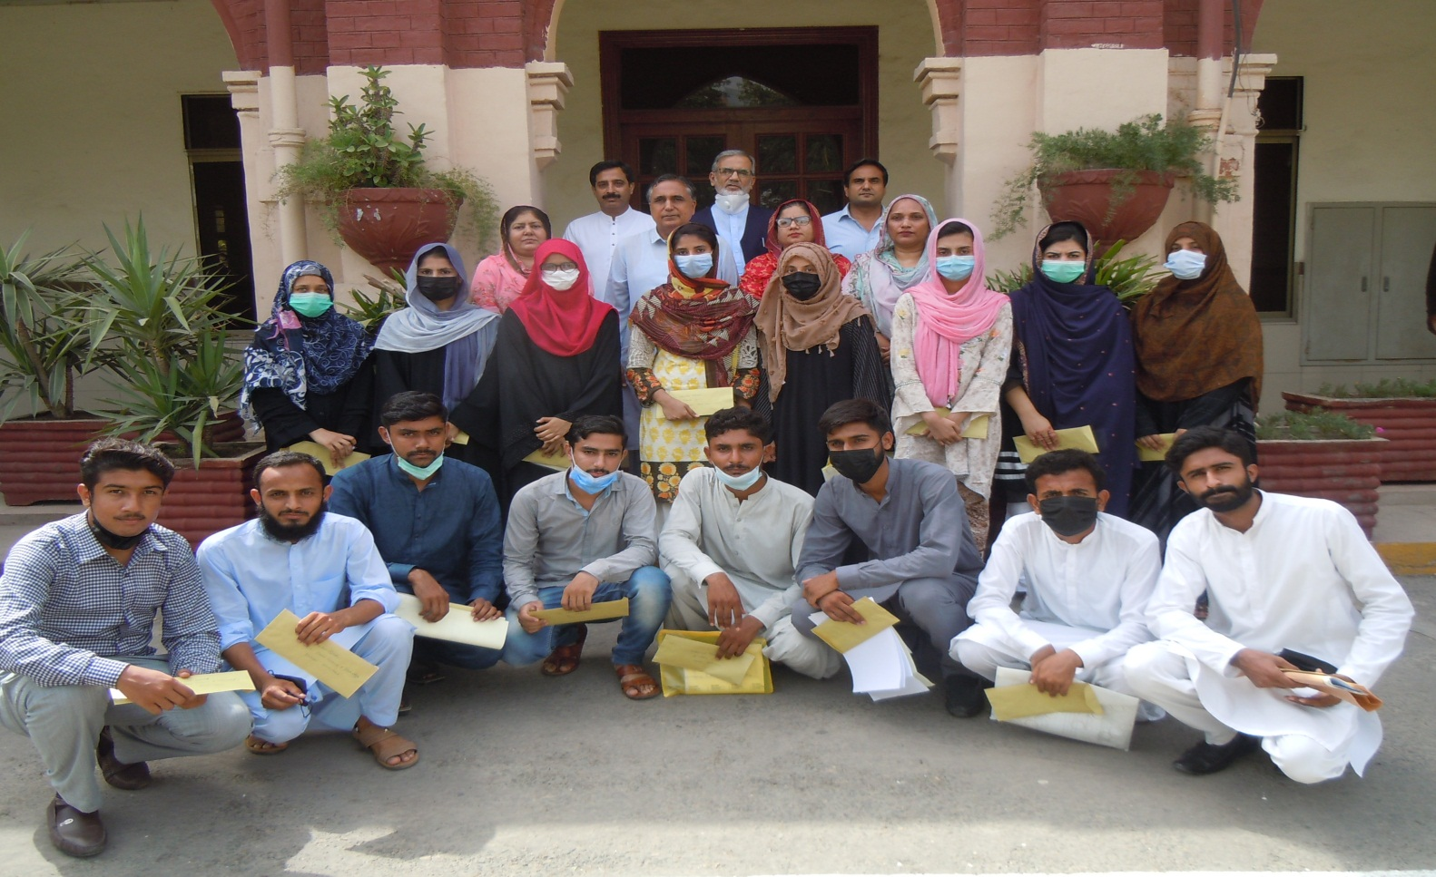

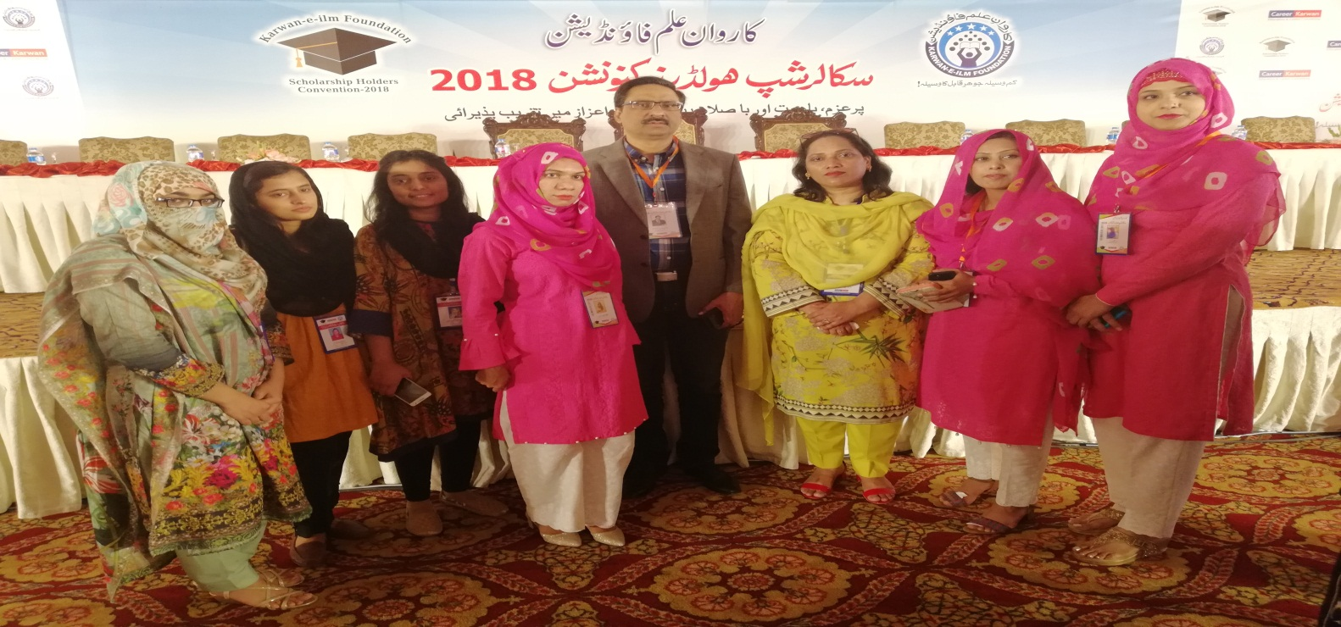

SDG 2 ZERO HUNGER
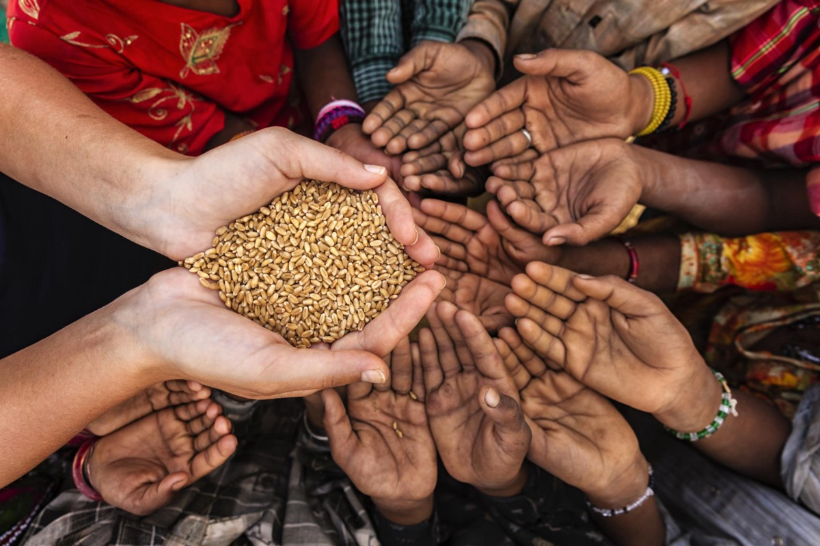

The Sustainable Development Goal (SDG) 2 is one of the 17 SDGs established by the United Nations in 2015 which aims to achieve zero hunger by 2030. The rise in food insecurity over the years has become a concerning global issue as the number of hungry and undernourished people continues to increase as a result of war, climate anomalies, poverty and increase in population in certain parts of the world. In addition, the increase in international food prices has severely impacted food production costs, particularly in food-exporting countries. As a result, countries have sought ways to protect themselves from price shocks by imposing export restrictions. According to the UN, an estimated 821 million people in the world suffered from food hunger in 2018. Currently, the rise and consequences of the coronavirus adds further challenges to achieving the zero hunger target by 2030 and may not be achieved if we fail to act.

ROLE OF GOVERNMENT COLLEGE UNIVERSITY, FAISALABAD IN ERADICATE POVERTY
In spite of all challenges facing by the country, government College University, Faisalabad is striving hard to do research related to food and nutrition, conduct training sessions and awareness seminars for faculty and students to control hunger and starvation. The University is also involved to make SOPs to food safety and security. The Department of Food Sciences is doing its job in true letter and spirit. The University is offering programs (BS, Msc, M.Phil & PhD) in Food Science and Nutrition.
The vision and Mission of the department is also representing the needs and the preconditions of the SDG Zero Hunger:

Vision & Mission of the department of Food Sciences
To produce high caliber graduates in the field of Food Science & Technology who will be well equipped through the training they receive, to support the rapid changes in food industries and sustain the industrial and economic development of Pakistan.
This vision is pursued in par with core values of the University which are integrity, excellence, teamwork, discipline and dedication to work. The department has pursued its teaching and research program in recognition of the fact that the food industry in Pakistan is still in its fledging state. Hence it is important that this program is offered to train the needed manpower and expertise that will help the industry and will produce the healthy community that will contribute to accelerate the economic development of country.
The department selects courses that are aimed at offering the students a good understanding of the basic principles of Food
Technology according to the growing and dynamic needs of food industry. According to the international education standards for degree program in Food Technology, the course content of any undergraduate syllabus should cover the following categories: Food Chemistry and Analysis, Food Safety and Microbiology, Food Processing and Engineering, Applied Food Science. This
degree program is not only producing skill technologist but also enhance the awareness regarding the issue that ultimately will uplift the economic status of the country. The department of Food Sciences has MOUs with many National & International Organizations.

MOUs
- Laboratoire d’Ingénierie des Biomolécules (LIBio), Université de Lorraine, France.
- Department of Food Bioprocessing and Nutrition Sciences, North Carolina State University, USA
- Faisalabad Confectionary Association, Pakistan
- Engro Foods Limited, KarachiHalal Research Council, Pakistan
- The Halal Science Centre Chulalongkorn University, Thailand
- Pakistan Council for Scientific and Industrial ResearchThe University of
- Gambia
- Kyungpook National University, South Korea
- Iowa State University, USA
- Amanah Halal Research Centre, Germany
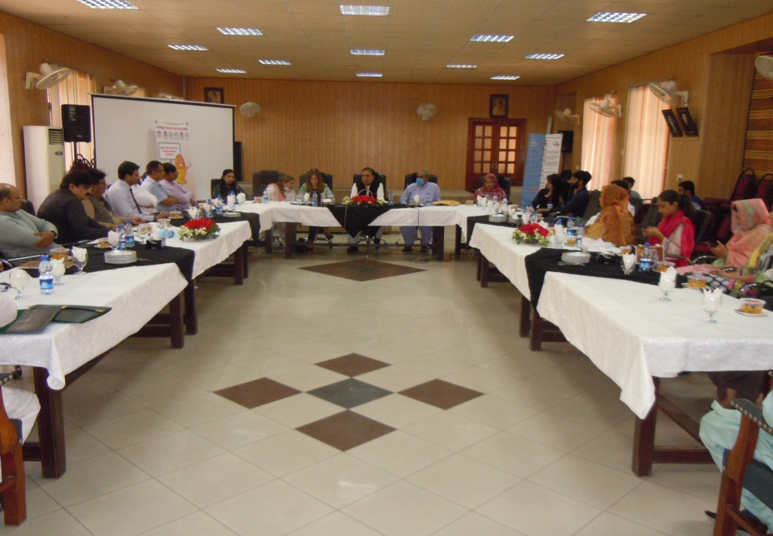
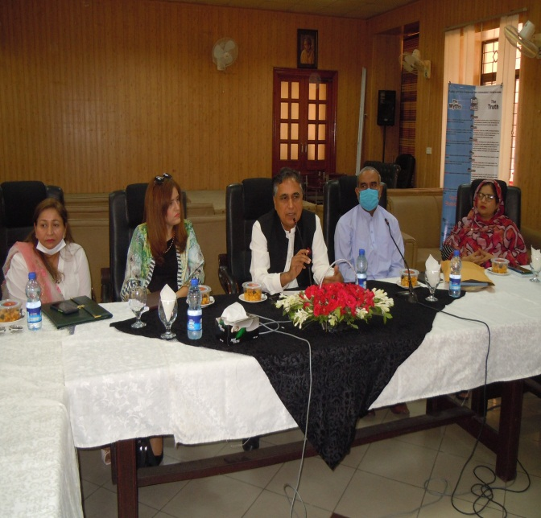

World Food Day
The Department of Food Science, GCUF conducted an Advocacy Seminar on World Food Day
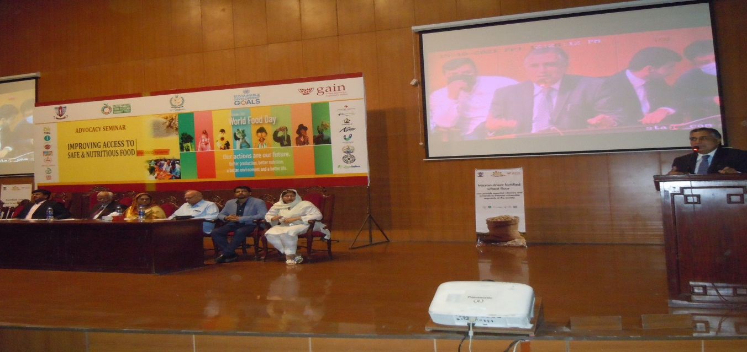
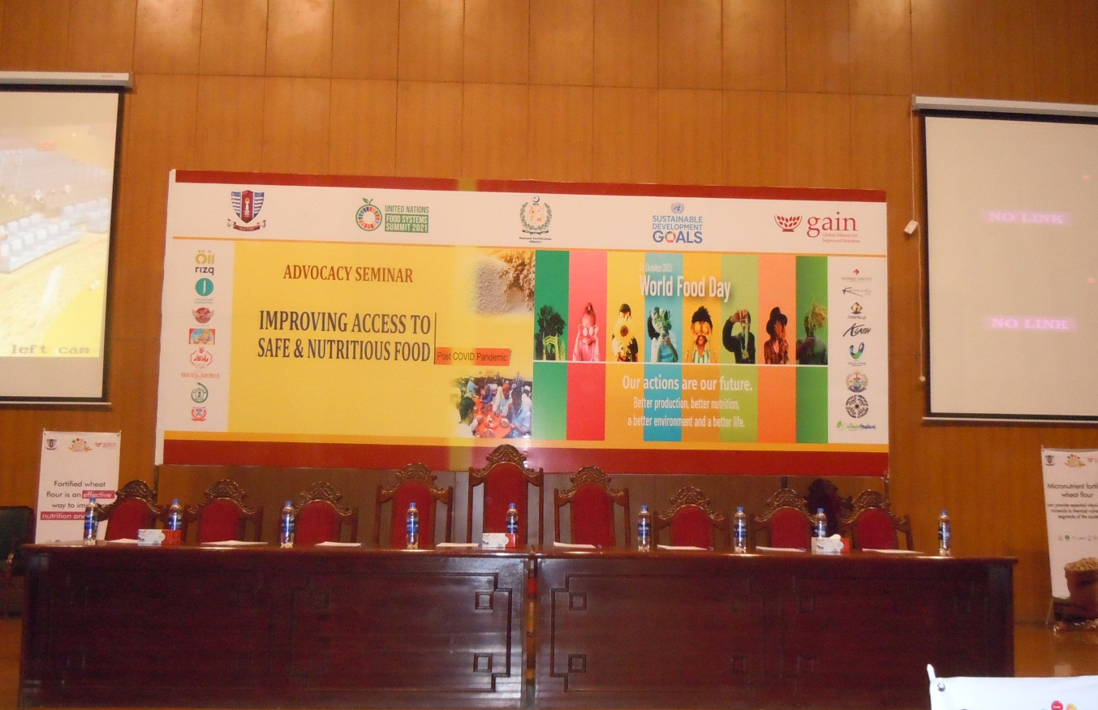

The department of Food Science has also conducted a Policy Dialogue on Food System

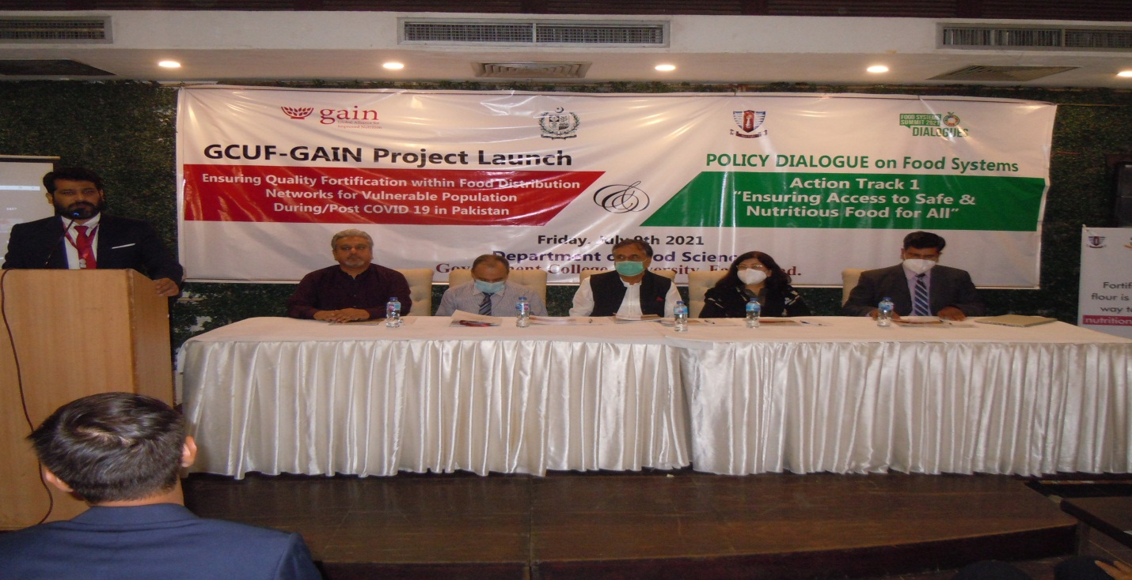

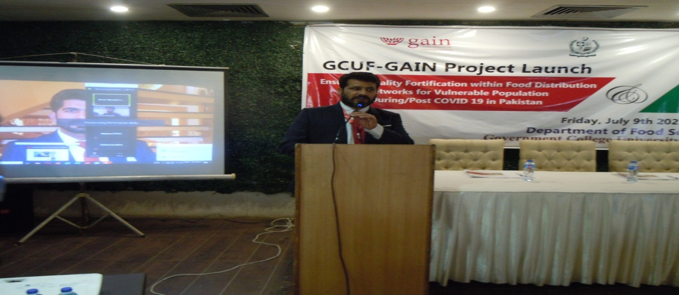

GAIN-GCUF PROJECT
GAIN-GCUF Project “Ensuring Quality Fortification within Food Distribution Networks For Vulnerable Populations During/Post COVID in Pakistan (USD 155000).
Objective
This study is focused to Improve intakes of micronutrients among poor and vulnerable in Pakistan during and post-COVID pandemic by ensuring the availability and distribution of fortified wheat flour through safety net programs (food / meal distribution networks).
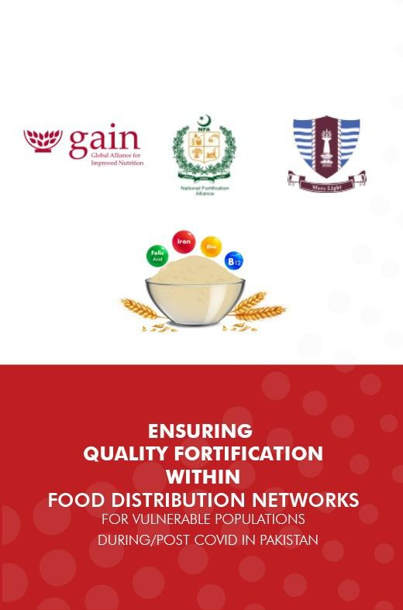

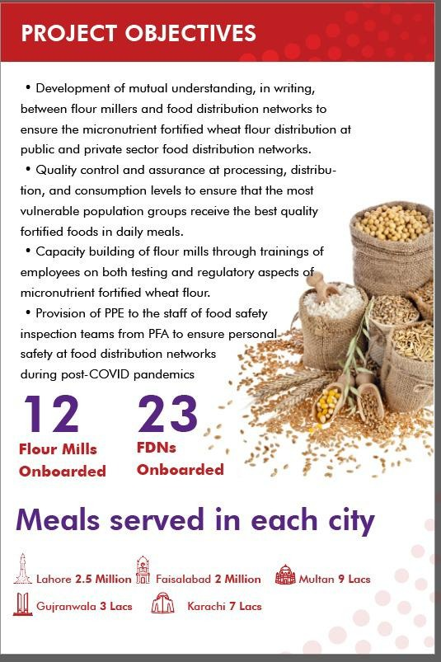
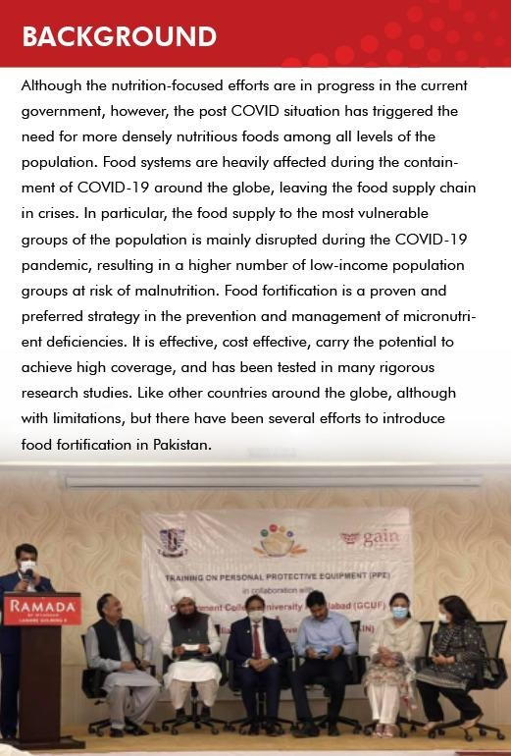

CAPACITY BUILDING
Through seminars and trainings under GAIN-GCUF program this project provided capacity building to the students, faculty and professionals:
Training | Training type | Audience | Audience Count | Training Session Duration | Venue | Date
1 | Awareness session on Fortification and sensitization | - Flour Mill management  - Quality Assurance Lab & Technical Persons of Flour Mill  - Food authorities  - FDN Management  - Project Team and Students | 30-50 Persons | One Day training | Faisalabad | 03-07-2021
2 | Awareness session on Fortification and sensitization | - Flour Mill management  - Quality Assurance Lab & Technical Persons of Flour Mill  - Food authorities  - FDN Management  - Project Team and Students | 30-50 Persons | One Day training | Lahore | 05-07-2021
3 | Awareness session on Fortification and sensitization | - Flour Mill management  - Quality Assurance Lab & Technical Persons of Flour Mill  - Food authorities  - FDN Management  - Project Team and Students | 30-50 Persons | One Day training | Multan | 07-07-2021
4 | Awareness session on Fortification and sensitization | - Flour Mill management  - Quality Assurance Lab & Technical Persons of Flour Mill  - Food authorities  - FDN Management  - Project Team and Students | 30-50 Persons | One Day training | Gujranwala | 09-07-2021
5 | Awareness session on Fortification and sensitization | - Flour Mill management  - Quality Assurance Lab & Technical Persons of Flour Mill  - Food authorities  - FDN Management  - Project Team and Students | 30-50 Persons | One Day training | Rawalpindi | 10-07-2021
6 | On-site practical training on sampling and spot testing RTKs | - Flour Mill management  - Quality Assurance Lab & Technical Persons of Flour Mill  - Project Team and Students | 25-40 Persons | One Day training | Faisalabad | 12-07-2021
7 | On-site practical training on sampling and spot testing RTKs | - Flour Mill management  - Quality Assurance Lab & Technical Persons of Flour Mill  - Project Team and Students | 25-40 Persons | One Day training | Lahore | 14-07-2021
8 | On-site practical training on sampling and spot testing RTKs | - Flour Mill management  - Quality Assurance Lab & Technical Persons of Flour Mill  - Project Team and Students | 25-40 Persons | One Day training | Multan | 16-07-2021
9 | On-site practical training on sampling and spot testing RTKs | - Flour Mill management  - Quality Assurance Lab & Technical Persons of Flour Mill  - Project Team and Students | 25-40 Persons | One Day training | Gujranwala | 16-07-2021
10 | On-site practical training on sampling and spot testing RTKs | - Flour Mill management  - Quality Assurance Lab & Technical Persons of Flour Mill  - Project Team and Students | 25-40 Persons | One Day training | Rawalpindi | 17-07-2021
11 | Practical Training on Fortification Process and QAQC activities | - Flour Millers  - Quality Assurance Lab personnel related to Food Standard from Flour Mills  - Project Team and Students  - Food authorities | 30-50 Persons | One Day Training | Faisalabad | 19-07-2021
12 | Practical Training on Fortification Process and QAQC activities | - Flour Millers  - Quality Assurance Lab personnel related to Food Standard from Flour Mills  - Project Team and Students  - Food authorities | 30-50 Persons | One Day Training | Lahore | 21-07-2021
13 | Practical Training on Fortification Process and QAQC activities | - Flour Millers  - Quality Assurance Lab personnel related to Food Standard from Flour Mills  - Project Team and Students  - Food authorities | 30-50 Persons | One Day Training | Multan | 23-07-2021
14 | Practical Training on Fortification Process and QAQC activities | - Flour Millers  - Quality Assurance Lab personnel related to Food Standard from Flour Mills  - Project Team and Students  - Food authorities | 30-50 Persons | One Day Training | Gujranwala | 24-07-2021
15 | Training on Food Safety Procedures | - FDNs Management  - FDNs Workers  - Food Serving Workers  - Supply chain personnel  - Project Team and Students  - Food authorities | 30-50 Persons | One day Training | Faisalabad | 27-07-2021
16 | Training on Food Safety Procedures | - FDNs Management  - FDNs Workers  - Food Serving Workers  - Supply chain personnel  - Project Team and Students  - Food authorities | 30-50 Persons | One day Training | Lahore | 29-07-2021
17 | Training on Food Safety Procedures | - FDNs Management  - FDNs Workers  - Food Serving Workers  - Supply chain personnel  - Project Team and Students  - Food authorities | 30-50 Persons | One day Training | Multan | 31-07-2021
18 | Training on Food Safety Procedures | - FDNs Management  - FDNs Workers  - Food Serving Workers  - Supply chain personnel  - Project Team and Students  - Food authorities | 30-50 Persons | One day Training | Gujranwala | 02-08-2021
19 | Training on Food Safety Procedures | - FDNs Management  - FDNs Workers  - Food Serving Workers  - Supply chain personnel  - Project Team and Students  - Food authorities | 30-50 Persons | One day Training | Rawalpindi | 04-08-2021
20 | Training on use of Personal Protective Equipments during Post Covid Inspections | - Operation Teams of Food Authority  - Food Handlers of FDNs  - Project Team and Students | 30-50 Persons | One day Training | Faisalabad | 06-08-2021
21 | Training on use of Personal Protective Equipments during Post Covid Inspections | - Operation Teams of Food Authority  - Food Handlers of FDNs  - Project Team and Students | 30-50 Persons | One day Training | Lahore | 09-08-2021
22 | Training on use of Personal Protective Equipments during Post Covid Inspections | - Operation Teams of Food Authority  - Food Handlers of FDNs  - Project Team and Students | 30-50 Persons | One day Training | Multan | 11-08-2021
23 | Training on use of Personal Protective Equipments during Post Covid Inspections | - Operation Teams of Food Authority  - Food Handlers of FDNs  - Project Team and Students | 30-50 Persons | One day Training | Gujranwala | 12-08-2021

24 | Training on use of Personal Protective Equipments during Post Covid Inspections | - Operation Teams of Food Authority  - Food Handlers of FDNs  - Project Team and Students |  | 30-50 Persons | One day Training | Rawalpindi | 14-08-2021
25 | Awareness session on Fortification and sensitization | - Flour Mill management  - Quality Assurance Lab & Technical Persons of Flour Mill  - Food authorities  - FDN Management  - Project Team and Students | 30-50 Persons |  | One Day training | Karachi | 16-08-2021
26 | On-site practical training on sampling and spot testing RTKs | - Flour Mill management  - Quality Assurance Lab & Technical Persons of Flour Mill  - Project Team and Students | 25-40 Persons |  | One Day training | Karachi | 18-08-2021
27 | Practical Training on Fortification Process and QAQC activities | - Flour Millers  - Quality Assurance Lab personnel related to Food Standard from Flour Mills  - Project Team and Students  - Food authorities | 30-50 Persons |  | One Day Training | Karachi | 19-08-2021
28 | Training on Food Safety Procedures | - FDNs Management  - FDNs Workers  - Food Serving Workers  - Supply chain personnel  - Project Team and Students  - Food authorities | 30-50 Persons |  | One day Training | Karachi | 20-08-2021
29 | Training on use of Personal Protective Equipments during Post Covid Inspections | - Operation Teams of Food Authority  - Food Handlers of FDNs  - Project Team and Students | 30-50 Persons |  | One day Training | Karachi | 21-08-2021

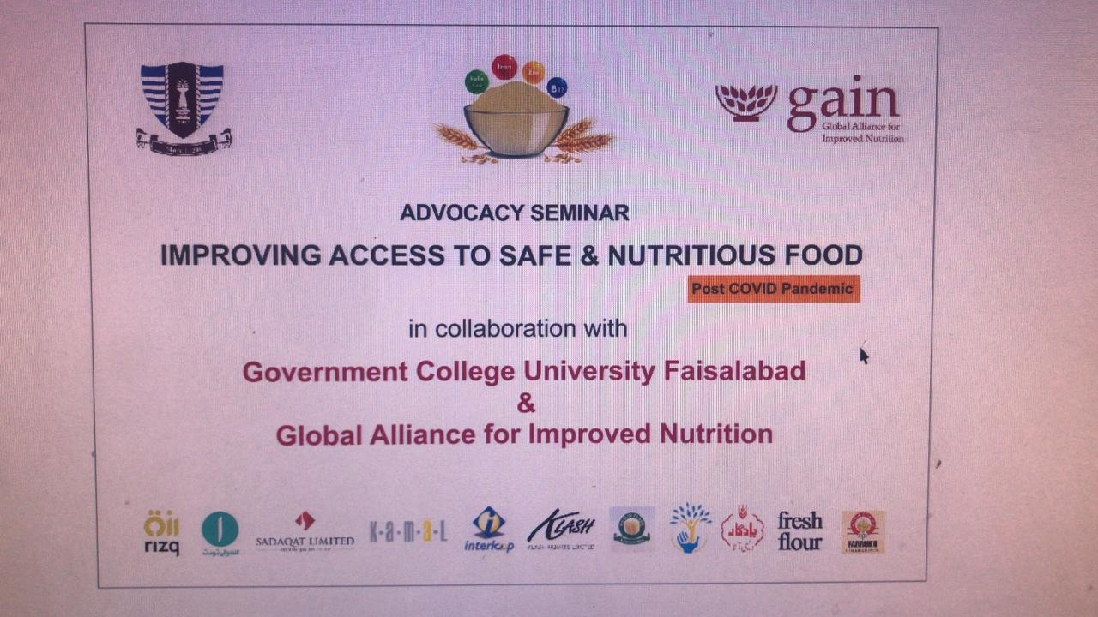
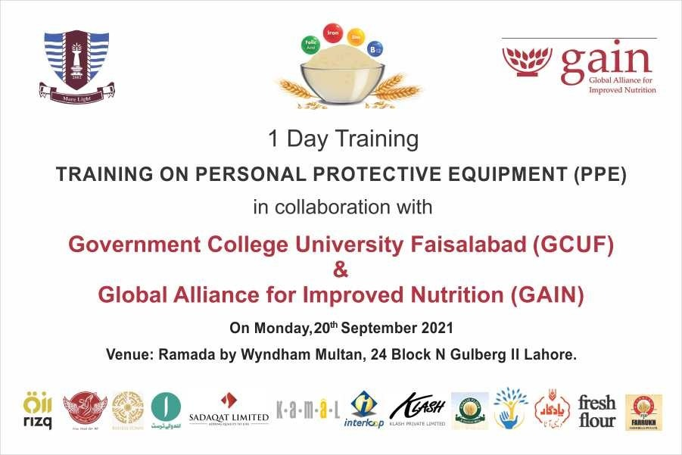
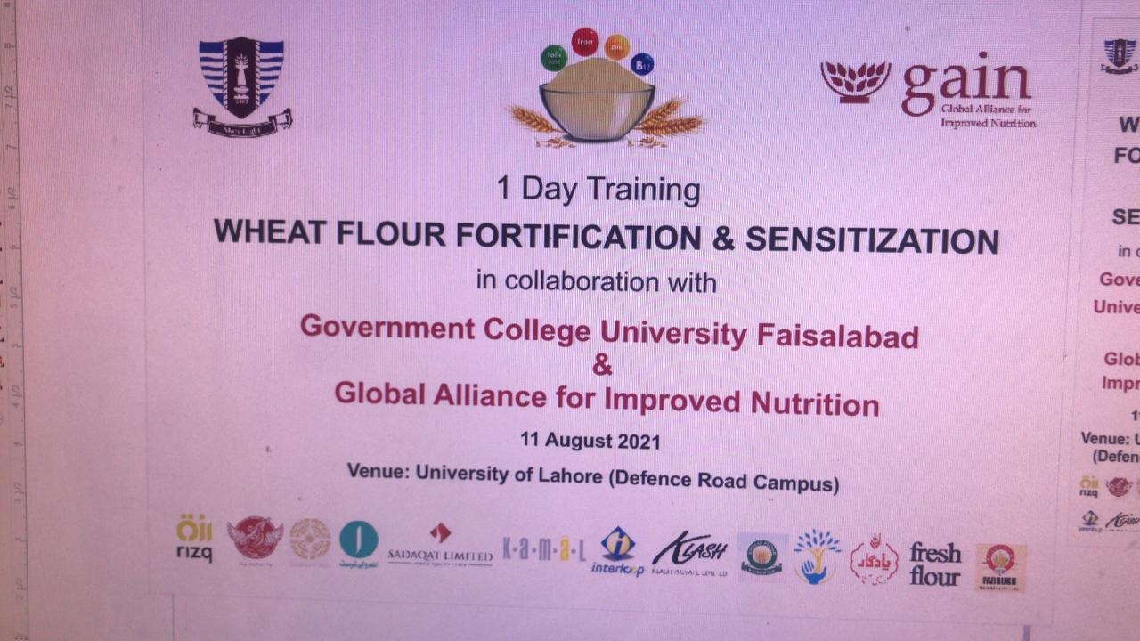

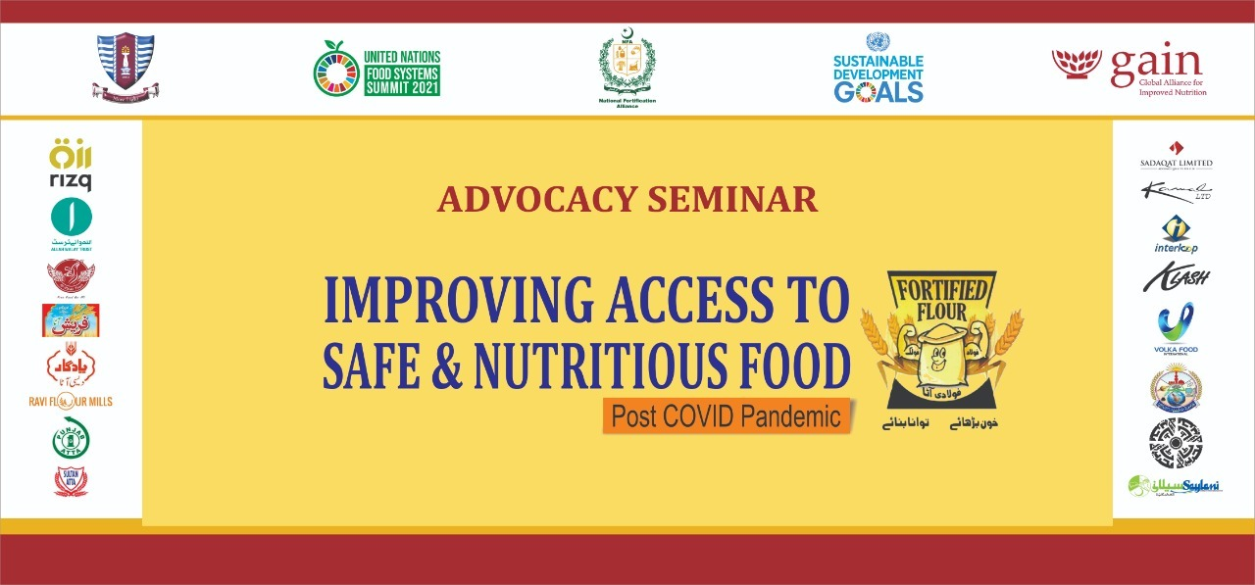
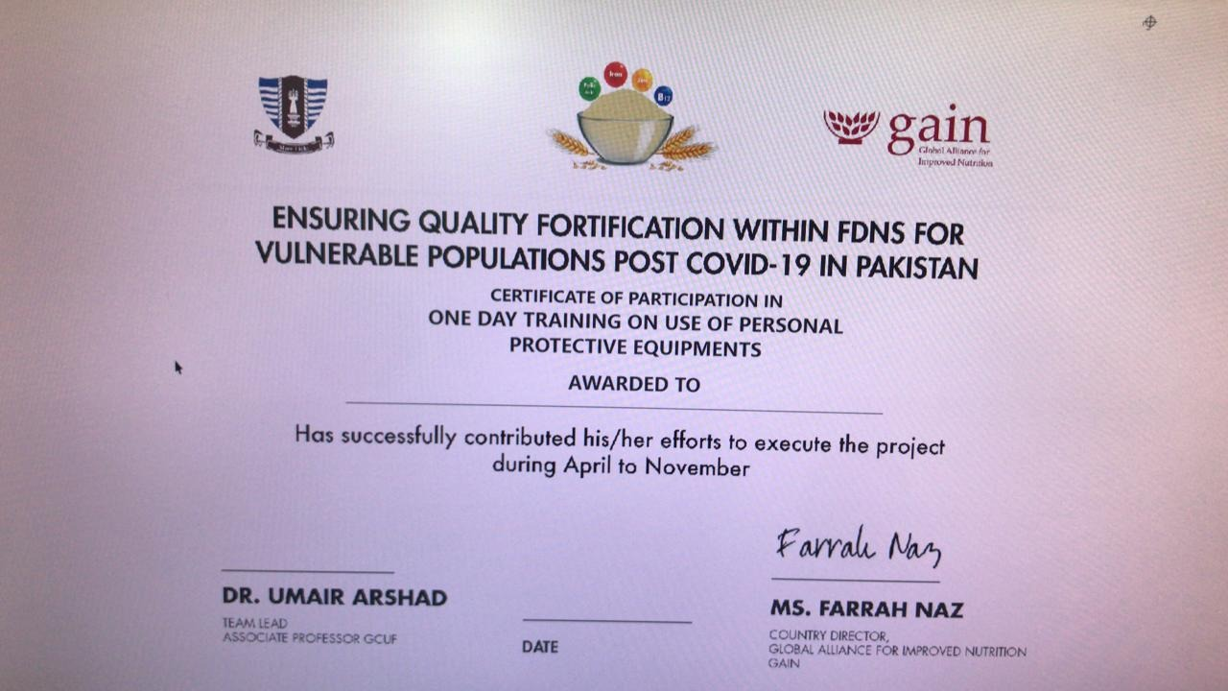

Internship
This project provided Internship of more than 400 students in different relevant industries through industrial linkages.
Sr. # | Industry Name (Internship) | No of students
01 | Ayub Agricultural Research Institute, Faisalabad | 20
02 | Azhar Corporation (Pvt) Ltd. | 5
03 | Cakes & Bakes  Lahore | 8
04 | Commander Tea Company | 6
05 | Punjab Food Authority  Lahore | 30
06 | Fauji Foods | 4
07 | FLOUR MILLS ASSOCIATION | 15
08 | JMUIM HALAL PAKISTAN | 3
09 | Innovative Foods | 6
10 | United Industries Ltd (UIL),  Faisalabad | 8
11 | Pizza Hutt, Pakistan | 8
12 | REHMAT FLOUR MILL | 6
13 | MALMO FOODS | 6
14 | METRO CASH AND CARRY | 4
15 | Mezan Beverages  Faisalabad | 6
16 | Mitchells PVT LTD. | 3
17 | Nutri factor | 4
18 | PREMA DAIRY FOODS | 5
19 | QAMAR TEA | 7
20 | QARSHI FOODS | 9
21 | LOTTE KOLSON Private Limited | 4
22 | VOLKA FOODS | 7
23 | YUMZ FOODS | 4
24 | Six B Food Industries | 8

SDG 3-Good Health and Well-Being
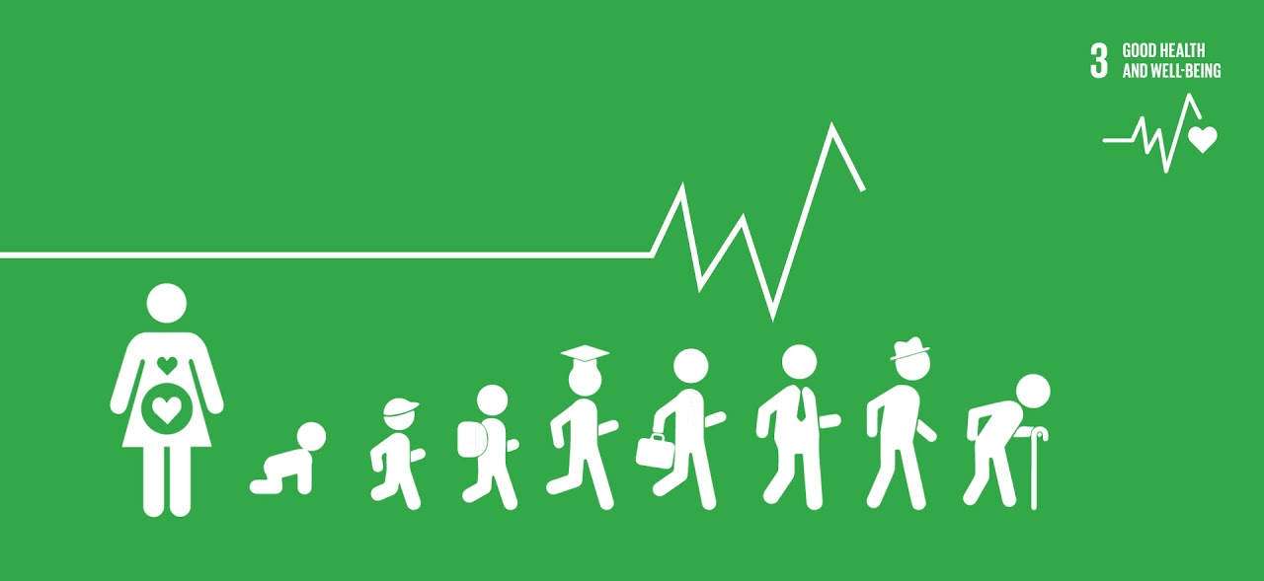

One of the 17 Sustainable Development Goals (SDGs) is promoting health and well-being that make up the 2030 Agenda for Sustainable Development . To take care of good health and well-being of people is become essential to sustainable development. Government College University, Faisalabad has taken many initiatives to ensure good health and well-being. We have departments of Food & Nutrition, Physical Therapy, Orthotics and Prosthetics, etc. in faculty of Medical Sciences. Qarshi Foundation Dispensary in collaboration with Eastern medicine Department. Sports and Physical Sciences departments of the university to improve and promote health & Wellbeing including hygiene, nutrition, family planning, sports, exercise, aging well, and other health and wellbeing related topics.
The Department of Applied Psychology is very dynamic and effective in conducting seminars, awareness walks, and charts competition and so on.

World Mental Health Day
World Mental Health Day was fully celebrated by the Department of Applied Psychology. All the faculty of GCUF and students have participated in awareness walks, seminars and chart Competition. The Vice Chancellor Prof. Dr. Shahid Kamal, Deans, Chairpersons/Incharges participated in all events of the day.
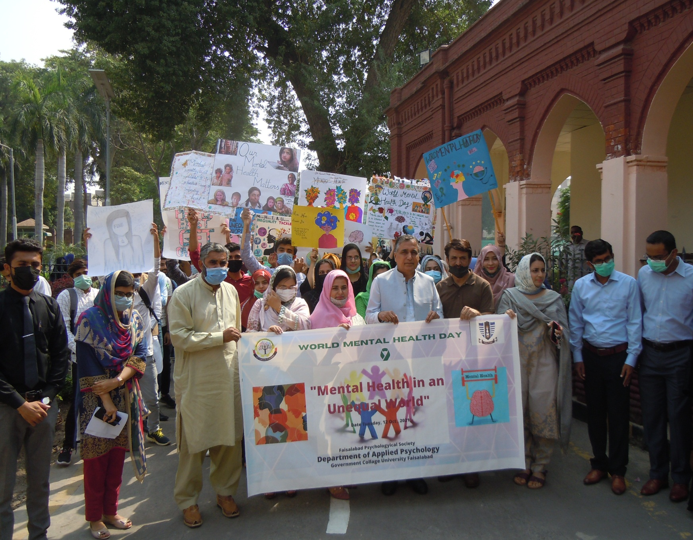

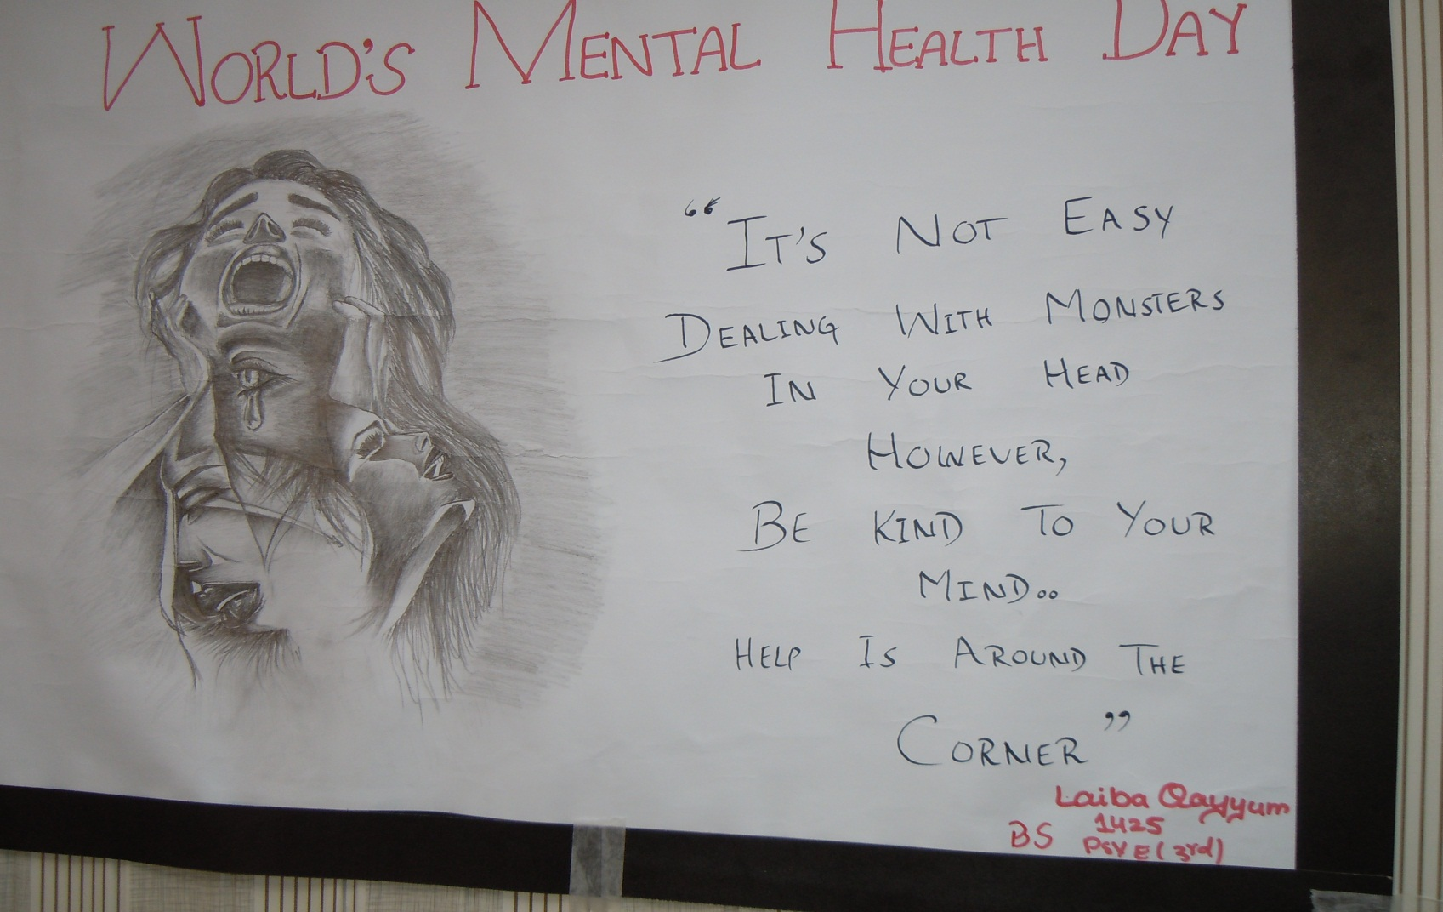

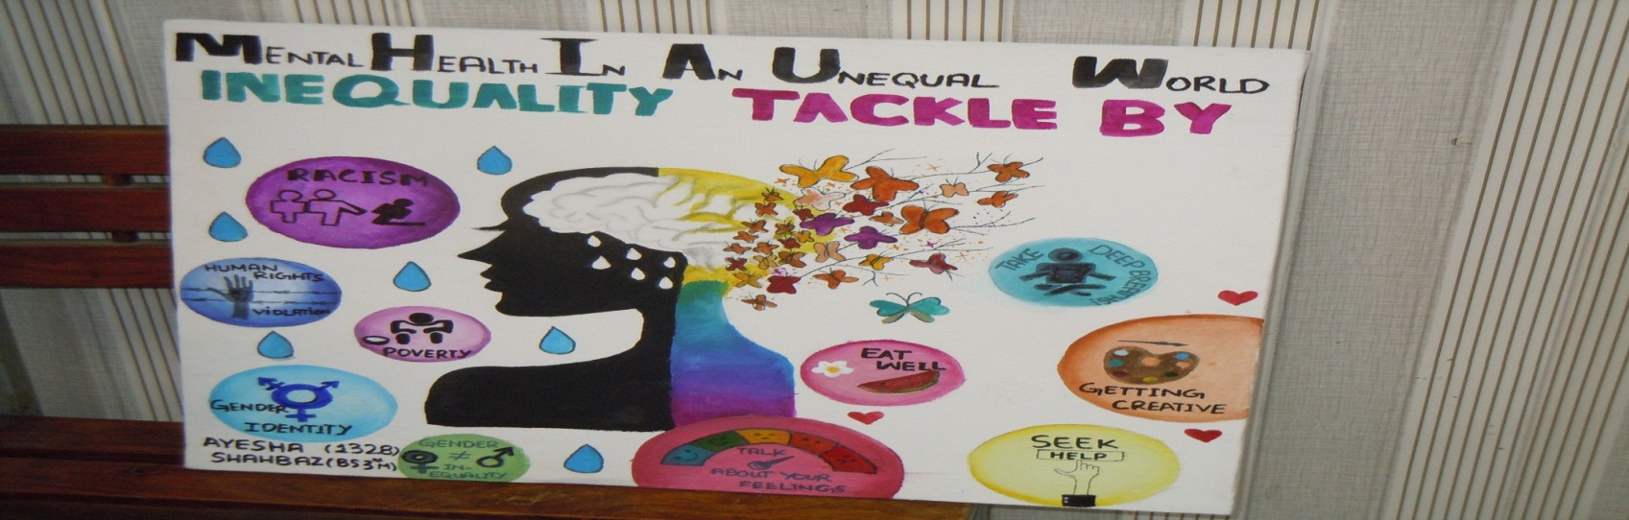

World Breast Cancer Day
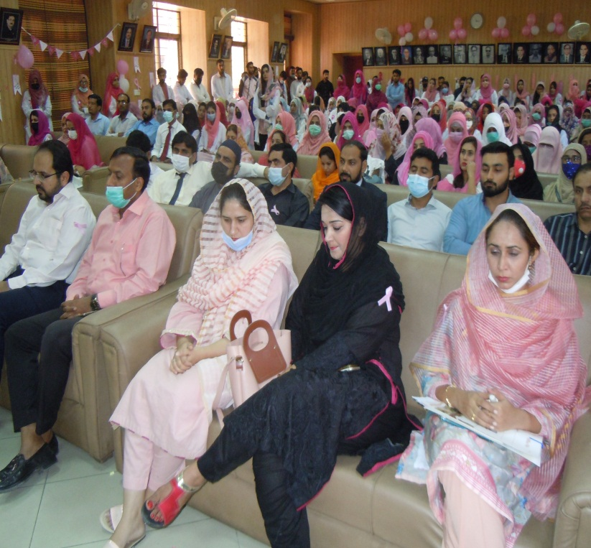
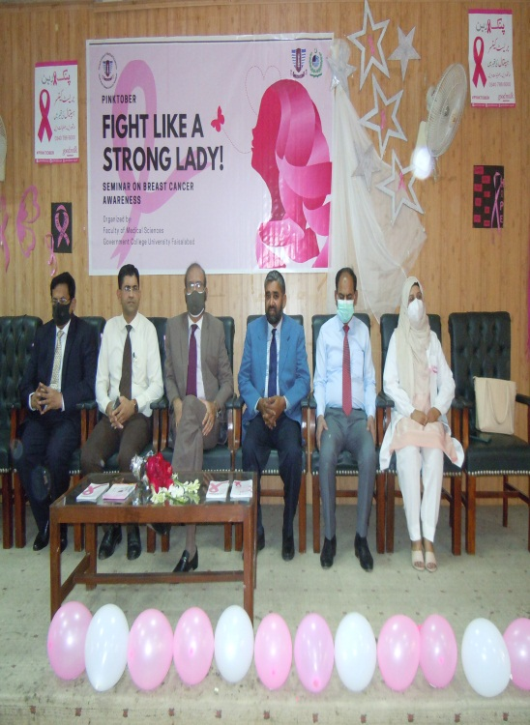

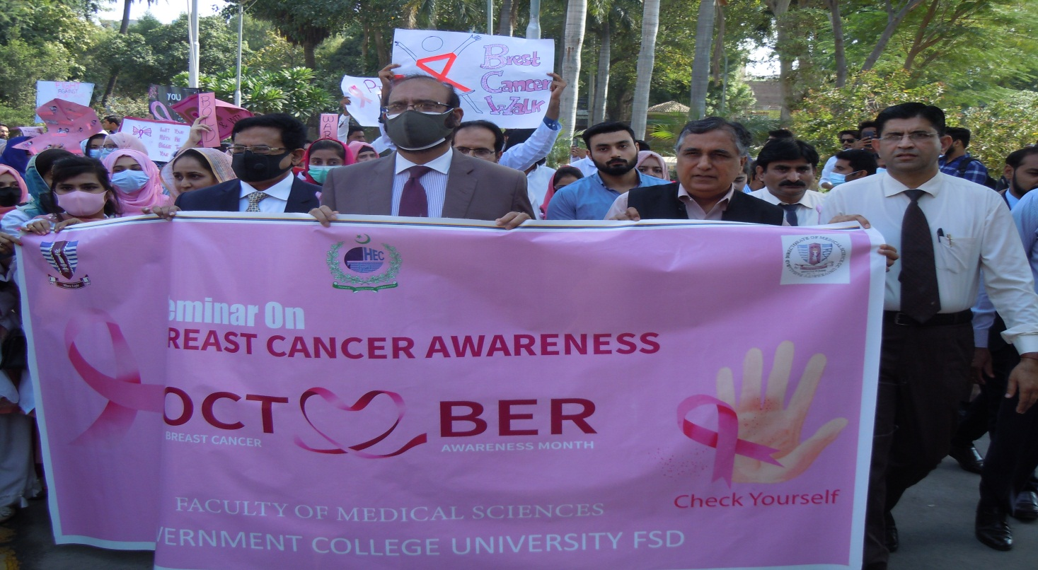

Medical Camp by Department of Eastern Medicine
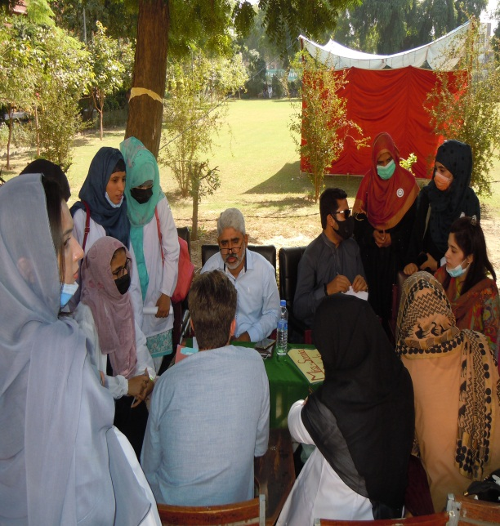
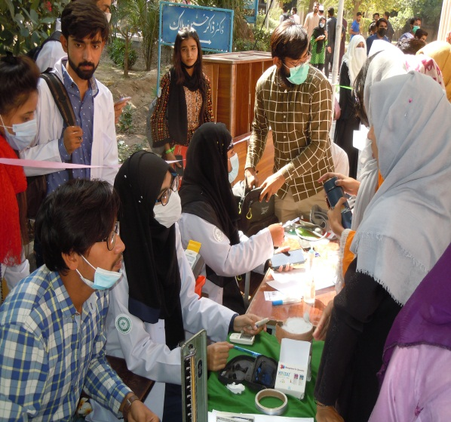
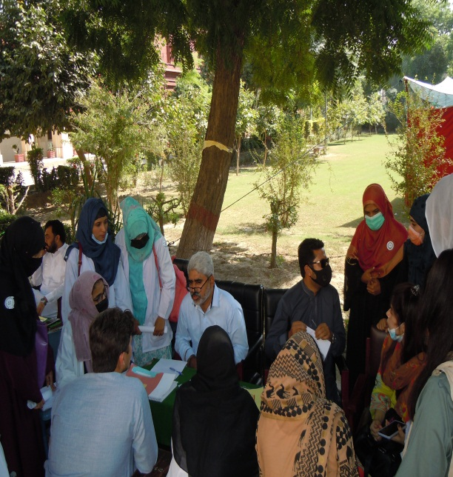
The department of Eastern Medicine has arranged a medical Camp for students and faculty.
1q5ruyh6y5r

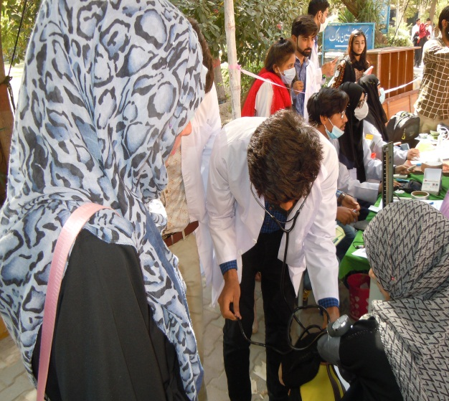

BLOOD DONATION CLUB GCUF
The Blood Donation Club of Government College University, Faisalabad is very functional. It arranges blood camps, awareness walks and seminars/workshops in collaboration with Blood Donation Organizations.

HEALTH CARE CENTRE AT FCUF
The Medical Health Centre provides first aid and outdoor medical facilities to the students. The outdoor medicines are also provided to the students and emergency cases are referred to Allied Hospital and DHQ hospital on University Ambulance. The staff members of the university are also facilitated at Health Centre in routine and emergency cases. The University provides the services to refer the University employees for outdoor and indoor medical treatment from Government / Private Hospitals on the panel of the university. The outdoor and indoor medical re-imbursement facility is also provided through the Medical Health Centre under the supervision of the Medical Re-imbursement Committee headed by Prof. Dr. Abid Rashid (Director Medical Sciences).
The Medical Health Care Centre provides first aid facilities to university athletes during university games. The Medical Health Care Centre also provides health facilities in new campus of the university. The health care centre also provides scholarship facility & rehabilitating facilities to disable students of the university. Furthermore, University Heath Centre has also honoured to provide medical facility in flood disaster areas i.e. District Chiniot,
District Jhang, Head Treemo and Athara Hazari on the direction of The Worthy Vice Chancellor in collaboration with Director, Directorate of Medical Sciences.

SOPS FOR THE RE-OPENING OF THE UNIVERSITY IN COVID-19
The opening of GCUF for teaching and research activities on campus is contingent upon the clear and detailed Standard Operating Procedures (SoPs). The SOPs are developed in compliance to the government directives and HEC’s guidelines. In the light of Government SOPs regarding COVID-19 Pandemic and HEC Guidelines, the University administration deliberated on the re-opening of the University in meetings: of the Deans, Directors, Transport Officer and Estate Care Officer held on 09-09-2020.

Sports activities at GCUF for Students and Faculty for mental and Physical Heath
Government College University, Faisalabad conducted Sport Festival annually for Mental and Physical health of the students and faculty. The students from all departments participated in the different sports and win prizes from the University and at National level.

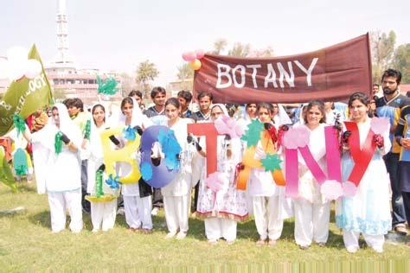
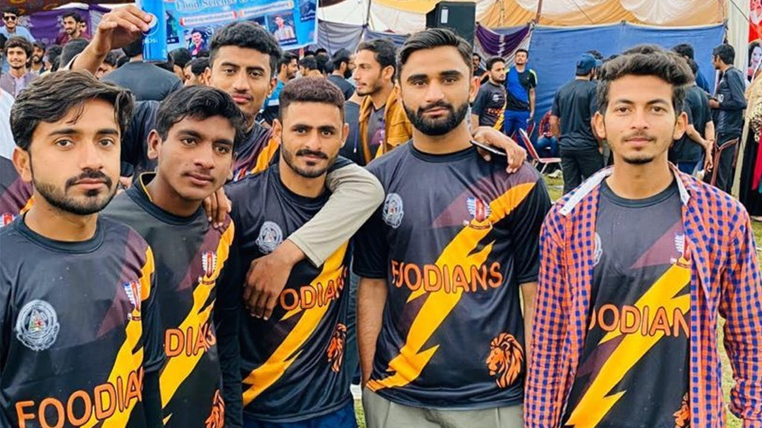

SDG 4 QUALITY EDUCATION


Government College University Faisalabad is striving to ensure quality education by all means. For this purpose, GCUF has appointed highly qualified faculty (701) and staff (796). The infrastructure of the University plays an important role for quality education. The construction of New Campus is proving of the commitment to provide better environment to the students and faculty.

QUALITY ENHANCEMENT CELL (QEC)
The Quality Enhancement Cell, Government College University, Faisalabad is fully functional and playing its role in true letter & spirit. Quality Enhancement Cell (QEC) is established under the guidelines of HEC for the purpose of enhancing, maintaining and monitoring quality of higher education. Government College University Faisalabad is among those pioneer universities in Pakistan who established QEC in 2006. The Higher Education Commission issued directions for establishment of QEC on Oct. 16, 2006. Hence, in October 2006, Government College University Faisalabad authorities constituted the cell according to the guidelines.

Vision:
The Vision of the Quality Enhancement Cell of Govt. College University Faisalabad is to become a benchmark in Quality of Research and Education among all HEC recognized universities.

Mission:
The Mission of the Quality Enhancement Cell, Govt. College University Faisalabad is to ensure and enhance the Quality of Higher Education and Establishment of Research Oriented Environment at Govt. College University, Faisalabad so that the students can play a vital role in the development of our mother-land “Pakistan”.
The primary task of QEC is to develop a system for conscious and consistent improvement in the performance of the University. The success of QEC depends on the collaboration and cooperation of all the stake holders. QEC is a monitoring, evaluating and suggestive body of the University having potential for ensuring quality by working out intervention strategies for the compliance of quality measures. To correspond and facilitate QEC in its working, faculty members are also part of its team.
QEC is mainly responsible to develop procedures for examples QEC collects department-wise data as bench mark, it also conducts evaluation including program monitoring, departmental review, student and employer feedback, reviews of Master’s, M. Phil and PhD degree programs, Institutional assessment Monitoring of implementation of the recommendations.
The Quality Enhancement Cell has acquired the membership of The Talloires Network, QEC-Network ((Network off Quality Enhancement Cells off Pakistani Universities, Asia Pacific Quality Network (APQN), Quality Assurance Agencies of Islamic World (IQA) and Pakistan Network for Quality Assurance in Higher Education Institutions (PNQAHI).
Quality Enhancement Cell is a progressive and dynamic organization of Government College University, Faisalabad which is moving at a faster pace due to keen interest of the Worthy Vice Chancellor Prof. Dr. Shahid Kamal to achieve distinctions in Quality Circles.

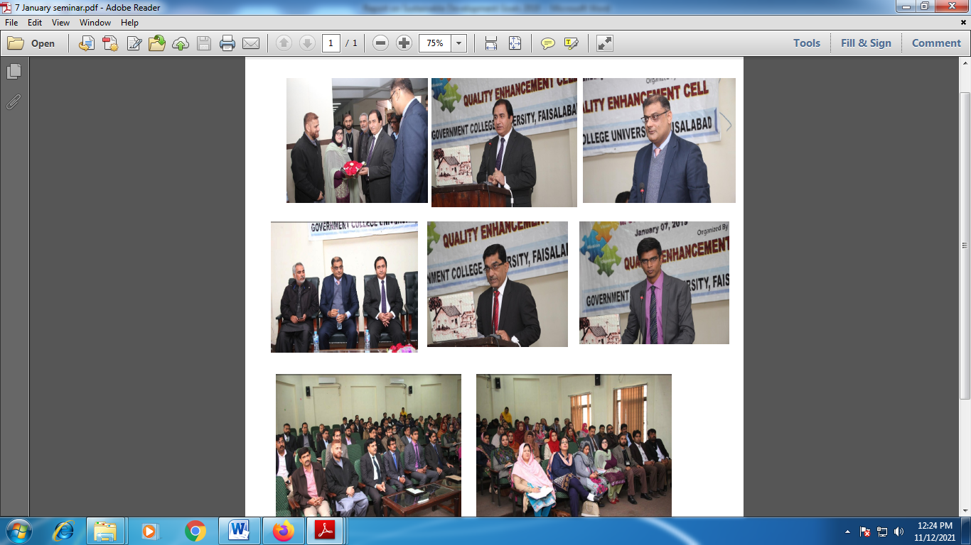

INFRASTRUCTURE AND FACILITIES FOR ENHANCING QUALITY OF EDUCATION

Hi-Tech Lab GCUF
Central Hi-Tech Lab has been established in Iqbal Block in 2014 at New Campus, Government College University Faisalabad. Central Hi-Tech Lab provides the opportunity to the scientists, researchers, students from Government College University, other Universities and R & D sections of the industries and non-government organizations for analysis in the field of biological, material, chemical and physical sciences.

Objectives
The main objectives of the Central Hi-Tech Lab are
- to provide assistance to promote scientific research in the university and other private organizations
- to provide platform for faculty members, researchers and students for hand-on trainings on different state-of-the-art instruments.

Facilities available
Chromatographic Section
(GC-MS/MS (Triple Quadruple), HPLC, GC-FID, Amino Acid Analyzer)
Spectroscopic Section
(FTIR and UV-Vis Double Beam Spectrophotometers)
Crystallography Section
(XRD Powder, XRD Single Crystal)
Elemental Analysis Section
(AAS, ICP-OES, Elemental Analyzer, CNS Analyzer)
Material Science Section
(Rheometer, DMA, DSC-TGA, Shear Tester)
Molecular Biology Section
(Thermal Cyclers Gradient)
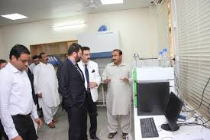
SOPs for analysis
Download the relevant form, filled and submit the charges for the analysis in the bank. Submit the dully signed and verified (from supervisors/chairperson) form along with paid voucher and samples to the office of Central Hi-Tech Lab.

Digital Library
The Government College University, Faisalabad also facilitating its students and faculty with HEC Digital Lab.
All the faculty, staff and research students are eligible for this service
- This is identity ID for GCUF
- On the university domain
- email@gcuf.edu.pk

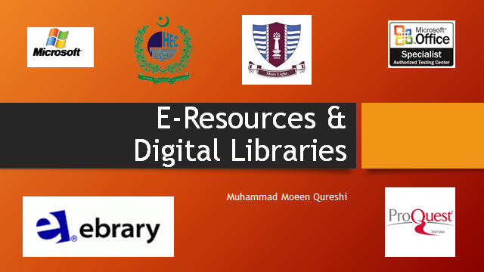

Campus Management System (CMS)
The Campus Management System, designed to promote paperless university administration. It is unique and comprehensive software. It host the features that allow users to maintain academic history of students with complete transparency in records and provides a medium for teachers, staff and administration to work in harmony.
The application comprehends all the features relevant to the university. The system has a complete role based access where in various resources are made available depending upon the role assigned.
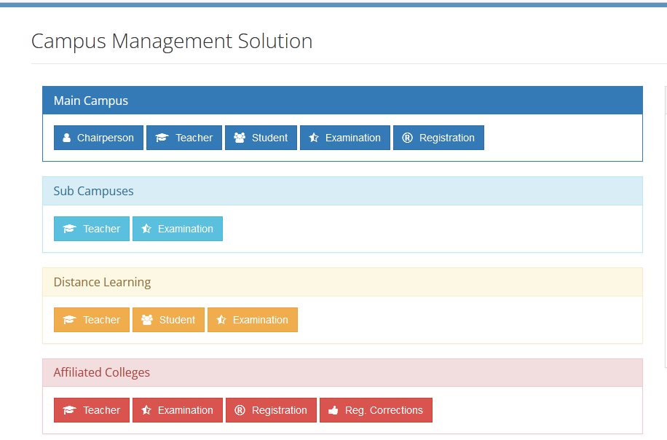

SDG-5 GENDER EQUALITY

Ending all discrimination against women and girls is not only a basic human right, it’s crucial for sustainable future; it’s proven that empowering women and girls helps economic growth and development.

