A Comprehensive Database / Repository Of Industries / Stakeholders / Mentors / Corporate Partners For Startups

Sr. No. | Name Of Mentor (Either Individual Or As Corporate Body) | Field / Areas of Expertise | Contact # | Email | Industry/Institution Name | PIC
1 | Qaiser Ahmad | - Financial Development and Financial Inclusion | 0301 8652478 | qaiserahmad992@outlook.com | Masood Textile Mills Ltd. Faisalabad | 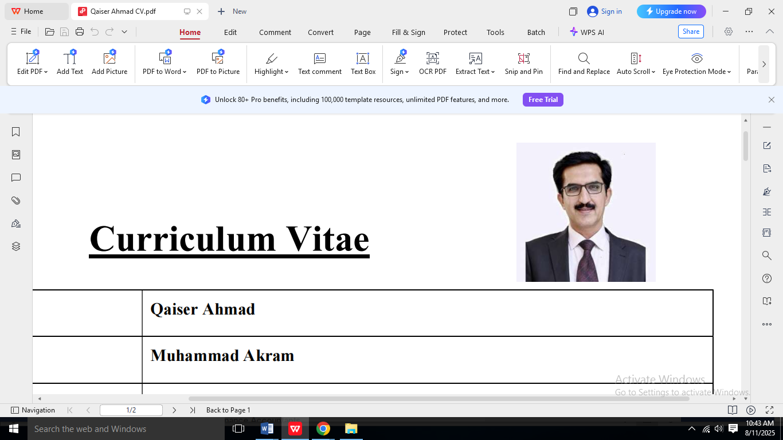
2 | Mr. Irshad Ali Sindhu | - Asset Management, Mess Management Housekeeping, Security of the Plant and Transportation issues  - HR Functions i.e Hiring, Recruitment, Training & Development, Compensation & Benefits, Organizational Development, Performance and Talent Management, | 03219997722 | Aliirshad1973@gmail.com | Sitara Peroxide Limited, Faisalabad | 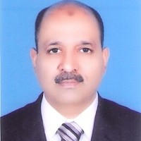
3 | Saad Arshad | - AI & Startups Product Development | 03219668123 | shaikhsaady@gmail.com | MilestoneZero Technologies | 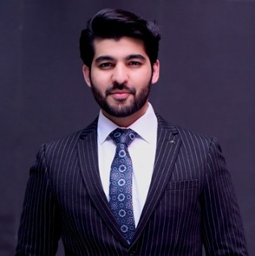
4 | Naveed Sarwar | - Full Stack Agentic AI Development  - LLMs, Web  - Mobile App Development | 0303 4766669 | naveed@techloset.com | Techloset Solutions.  https://techloset.com/ | 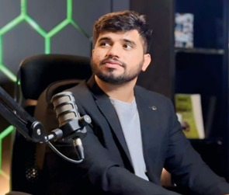
5 | Dr. Hammad Armghan | - Artificial Intelligence  - Energy Systems | +923007788876 | hammad.armghan@sz.tsinghua.edu.cn  hammad.armghan@cybergen.com | CyberGen USA / Tsinghua University / UC Berkeley | 
6 | Dr. Mazhar Sadiq | - Project Manager  - Business Analyst, Change Manager at Digital Transformation Department | 03445173957 | mazhar.sadiq@interloop.com.pk | Interloop Ltd | 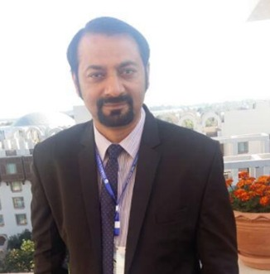
7 | Kainat Rizwan | - Artificial Intelligence  - Cyber Security | 03040972841 | kainat.rizwan10@gmail.com | KaiRiz Cyber Technologies  The Millennium Universal College TMUC | 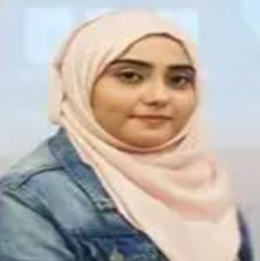
8 | Imran Khan | - Sr. BI Consultant in SQL Server technologies,  - Manages DWH schema objects i.e., Facts and Dimension tables.  - Provide UAT supports for SSRS reports  - Manage all SQL Server related database tasks on project | 0321 4884688 | Imran.sajjad@systemsltd.com  Imranmcs@hotmail.com | Systems Limited | 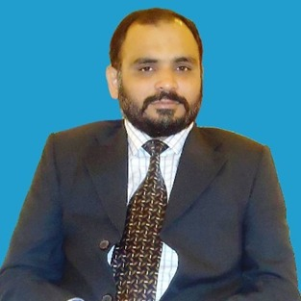
9 | Usama Jalil Kahlon Adv | - Provides expert advice on direct and indirect tax compliance, planning, and regulatory matters.  - Advises corporate clients on tax-efficient strategies, audits, and disputes with tax authorities. | 03217601303 | ujutt1@gmail.com | Tax Consultant – JK Law Associates  SECRETARY HUMAN RIGHTS COMMITTEE – PUNJAB BAR COUNCIL | 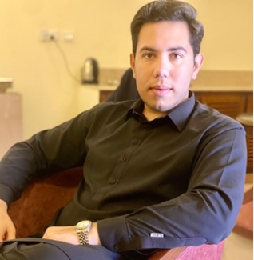
10 | Prof. Dr. Mubashir Mehdi | - Entrepreneurship  - Branding, Marketing and Value Addition | 03364313172 | mubashir.mehdi@mnsuam.edu.pk | MNS University of Agriculture Multan | 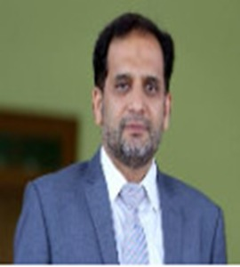
11 | Benish Sarfraz | - Entrepreneurship  - Agribusiness and Marketing | 03027558536 | Benish.sarfraz@mnsuam.edu.pk | MNS University of Agriculture Multan | 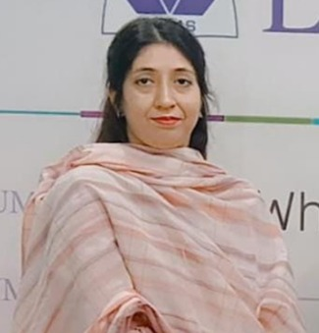
12 | M. Imran Munawar | - Marketing  - Entrepreneurship | 0333 2767676 | imranmunawar.bic@gmail.com | University of Agriculture Faisalabad | 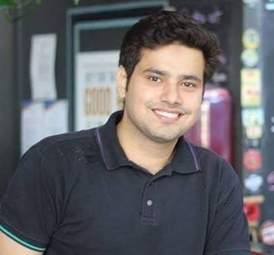
13 | Sajid Iqbal Sandhu | - National Agriculture Expert  - Expertise: Agri-business, Tunnel Farming | 92 321 8669044 | sajidsandhu@gmail.com | CEO, The Green Circle | 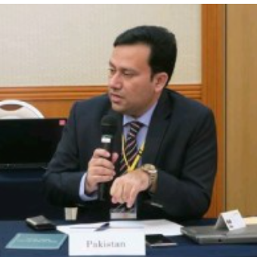
14 | Dr. Imran Khan | - Software Systems Engineering  - Technology Entrepreneurship | 92 333 2256428 | ikhan@iba.edu.pk | Founder and CEO, Techcanvas | 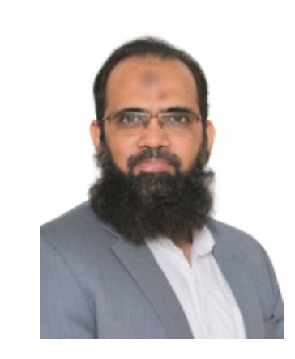
15 | Mr. Tahir Mahmood | - Turnaround Management  - Specialist  Management  - Consultant  Corporate Trainer | 92 300 8508288 | tahir@fe.com.pk | Chairman, Computer Society of Pakistan | 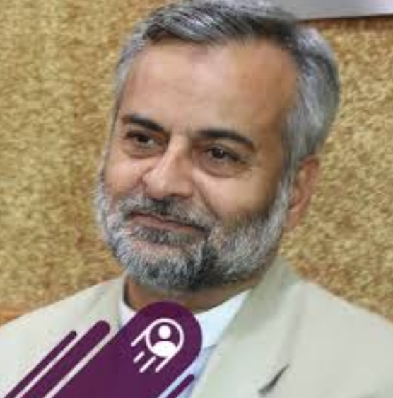
16 | Ms. Shakra Khurshid | - Patent Specialist/WIPO Certified IP Trainer/IP Consultant | 92 3054584042 | shakra.khurshid@ipo.gov.pk | Patent Specialist/WIPO Certified IP Trainer/IP Consultant | 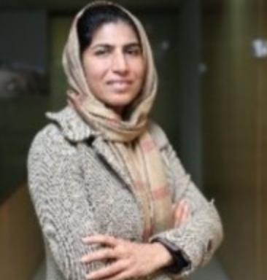
17 | Dr. Farrukh Hassan | - Microbial Biotechnology | 92 306 1213672 | linkedin.com/in/farrukh-hassan-057692150 | CEO, The First Bio-fertilizer Company | 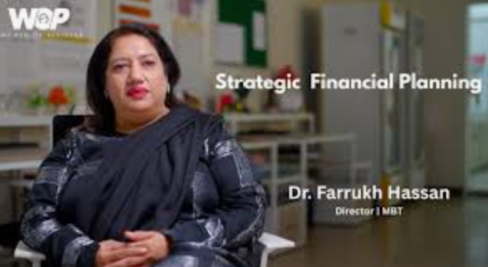
18 | Tahir Jabbar |  | 9203072166212 | tahir_jabbar@parco.com.pk | Group Head (Telecom/SCADA)  Pak-Arab Refinery Ltd(PARCO) Karachi, Pakistan) | 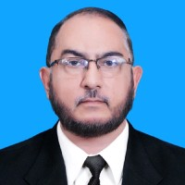
19 | Dr. Muhammad Shahbaz |  | 923336588 618 | shahbaz.ft@mnsuam.edu.pk | Associate Professor/Chairman  Department of Food Science and Technology, Faculty of Food and Home Sciences  MNS-University of Agriculture Multan, Pakistan | 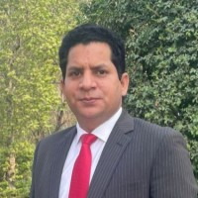
20 | Prof. Dr. Tahir Zahoor | - Food Sciences: Technology, Human Nutrition, Dairy, Safety, Microbiology and Services management  - Value addition in Agriculture  - Nutraceutical and functional foods  - Development of Cost-Effective Food Processing Technology  - Problem Oriented Research for Food Industry | 92 300 6633238 | Tahir.zahoor@niu.edu.pk | Dean, faculty of Applied Sciences  Director ORIC  NUR International University | 